(Approx. 892 words)

Is the CPU the PC Shopping Key?
News and/or opinion from Paul Baecker, Editor, Sterling Heights Computer Club MI
June 2019 issue, WYSIWYG
www.shcc.org
newsletter (at) sterlingheightscomputerclub.org

With the pending demise of all Microsoft support on January14, 2020 for what is possibly their best operating system to date (Windows 7), many users will be shopping for a new PC as one of their solutions. Another solution could be to install Linux onto that Windows 7 PC as a ‘dual-boot’ configuration, so that the user can safely surf the web using the Linux boot option, but still maintain the Windows partition with needed Windows applications (just don’t go web surfing with it).

If a new PC is the choice, how to go about it? Well, I look at buying a new computer sort of like buying a new car (or SUV if we believe the trends). What is the first thing about a new vehicle that we think of? I’d say it’s the engine. You can select a 4-cyl or 6-cyl or hybrid or electric motor. But once you buy it, can you return to the dealer and switch it if you have second thoughts? Nope. I look at this akin to choosing a PC with a particular
CPU. Generally, you can’t switch the CPU (OK, you extreme tekkies, this column isn’t for you!) once you make your purchase. You can usually increase the RAM or switch from an HDD to an SSD, and such things that enhance the PC’s performance, but you’re stuck with the CPU performance that came with that sparkling new PC.

When you see 5 PCs on the store shelf, all with the same price, how to choose? How to select the ‘right’ PC, despite what the over-anxious salesperson might push you into buying? A little homework, that’s how. The www.passmark.com web site is your new pal. It compares relative performance among over 2700 CPUs from Intel and AMD. AMD is Intel’s primary PC CPU competitor, and a CPU brand certainly worth considering
(the two manufacturers keep leapfrogging over each other with new CPU technologies — Intel just advertises more, and you pay for that treat). The site also has other hardware benchmarking features (RAM, video cards, drives, much more), but we’ll stick to CPUs in this article.

To check the overall performance of a CPU on passmark.com (which is a FREE site), you do this:
- Go to www.passmark.com
- Select Benchmarks from the menu and then down to CPU Benchmarks.
- Click on the "Search for your CPU model" selection.
- The heading will be "CPU List". Below that, "Single CPU Systems."
- To the right of that, there is an empty box, with a "Find CPU" button next to it. This is where you'll enter the CPU model for which you want a ranking.

For example, a PC you're interested in contains an "Intel Core i7-8565U Processor at 1.8GHz" processor. Copy/paste the processor model (in this case, "i7-8565U") into
that box (without the quotes). A greyed box will open, listing all of the processors that pertain to that model (for example, there could be something like an i7-8565UX
model, too). It will list all of the CPUs in the same model family. For this 8565 CPU, there is only one model. The site is a bit finicky. You need to enter the proper
CPU ID including a dash — for example, like i7 (for Intel) or A10 (for AMD), and then the model number, usually with a dash between them — in order for the site to display it. Keep trying — you’ll get the hang of it quickly.
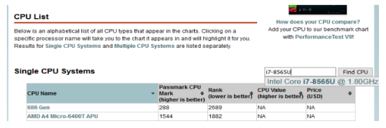
Click on the selection to get it entered in full in the box that was previously empty. It’ll look like this:
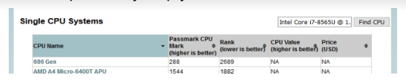

Then you can click on the Find CPU button, and you'll see the resulting ranking:
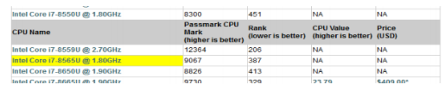
So, the CPU in this PC is ranked 387 for overall performance among about 2700 listed CPUs. Remember that "1" is the CPU with the highest overall performance (you
can click on “Rank” at the top of the listings to see everything in performance order — you can sort on any of the columns there). A ranking above 400 is pretty darned cool these days and will all-but-promise you a high-performing PC for many years to come.

This web site has many other features, but in my opinion, this CPU-performance ranking is the most useful to typical PC shoppers. The site can also compare up to
three CPUs at a time. Clicking on any of the CPUs in the list will display windows with additional qualities — power consumption, number of cores, clock speeds, pricing (which changes day-to-day), and more.

So, when you visit a store (or a retail web site) and observe so many PCs available to your wallet, consider making notes of the various CPUs in PCs in your price range. Peruse their overall performance on this site.

Also consider upping your price range just a bit to get a much-higher-rated CPU, knowing that later you can alter those other PC components to enhance that PC (RAM,
drive, etc.). Then go shopping. Some stores offer a return period with a full refund (avoid stores with so called ‘restocking fees’!!!), so that you can test drive your new digital toy at home, particularly useful since you really cannot put any PC to the test in a store.

Just ask about it.

